MAYESPARK PRIMARY SCHOOL



Art and Design Policy

Written by: Victoria Lockhart
Date: June 2021
Last Reviewed: July 2023
Next Review Date: July 2025
MAYESPARK PRIMARY SCHOOL

Art and Design Policy

Aims

At our school we intend for children to master Art and Design to such an extent that they can go on to have careers within Art and Design and make use of art effectively in their everyday lives.

Our children will be taught Art and Design in a way that ensures progression of skills, and follows a sequence to build on previous learning.

Our children will gain experience and skills of a wide range of formal elements of art in a way that will enhance their learning opportunities. This will enable them to use Art and Design across a range of subjects to be creative and solve problems, ensuring they make progress.

At Mayespark, we believe that art has always been a vital skill that helps to develop the children’s emotional literacy. Following the wider world events that have taken place we have found it more important than ever before to provide our children with an opportunity and the tools to express their emotions in a safe and creative way. Our Art and Design curriculum has been designed to ensure that children are provided with opportunities to express their feelings in a proactive and productive way.

Additionally, the curriculum aims to provide a broad and balanced variety of artists and movements from different cultures and periods across the world. The vision is to expose children to a diverse range of artists. These artists will correlate to the topic or theme of the year, will be reviewed on a cyclical basis and expanded over time.

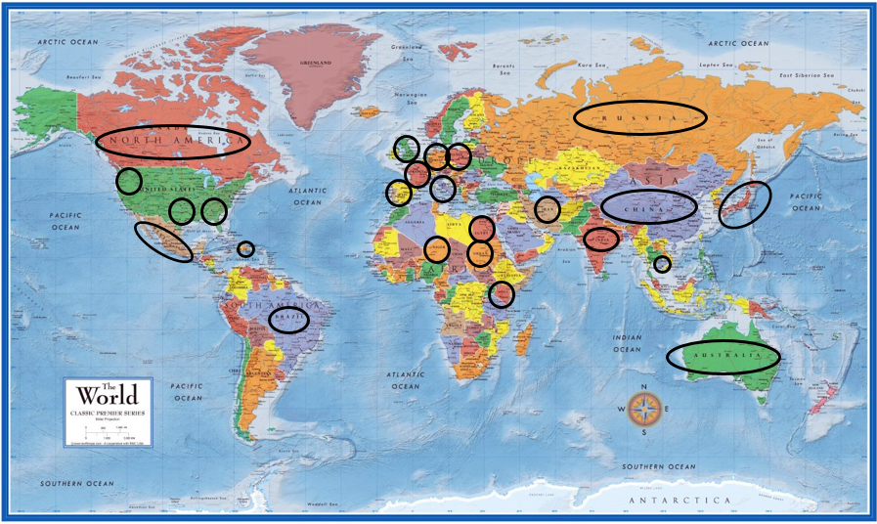

The Curriculum

We follow a broad and balanced Art and Design curriculum that builds on previous learning and provides both support and challenge for learners. We follow an Art and Design scheme that ensures progression of skills and covers all aspects of the Art and Design curriculum.

All classes have a scheduled Art and Design unit of work taught every half term in EYFS and Years 1 and 2 and once a term in Years 3-6.

Children’s work and pictures of their work will be stored on the school website for reference.

We want to ensure that Art and Design is embedded in our whole school curriculum and that opportunities for enhancing learning by using art are always taken.

Teaching sequence

Explore an Practise the
artist or art skills needed
movement. and replicate
the artist’s
techniques.

Assess and Plan, design evaluate and create
their own unique artwork
and others based on the
artwork skills developed.

Planning

Long term planning is based on a combination of Kapow Primary resources and teachers planning. All Art and Design unit of work will be taught in blocks so that children can master each skill or technique. Units are progressive in sequence both of individual lessons and progressive across the whole school, so that when a child returns to a unit (i.e. collage) they are building on their prior learning as identified on the medium term plans.

Key principles/ elements of art

The elements of art; colour, tone, shape and form, line, pattern and texture are taught in every year group. In KS1 these may be taught as an individual element across the whole unit of work. In lower key stage 2, each element may be examined as an individual lesson and combined for the final piece of art work. In upper key stage 2 these elements will be explored in conjunction with each other to develop an understanding that one or more of these elements may influence the others and drive the artwork’s composition or meaning.

Teaching and Learning

Warm-ups

As with all subjects, warm-ups and stretching are crucial to developing the right mindset for a subject. Just as in a PE lesson, we would stretch our muscles before kicking a ball; in art lessons we need to stretch our artistic muscles, prepare for creativity and imagination as well. Therefore, warm-ups are a vital part of the art learning structure.

Sketchbooks
At Mayespark every pupil has their own sketchbook. These are use to detail the art journey that the pupils take through each art unit as well as across their time at Mayespark. Pupils are encouraged to review these skecthbooks frequently at the beginning, during and at the end of each art unit and to reflect on the progress they have made as artists.
Sketchbooks are part of the child’s personal expression and all art should be appreciated and complimented by teachers but should not be altered by marking. Teachers will refer to the sketchbooks and final pieces of art work in order to assess and monitor each child’s progress.

Artwork
Art work is created with the intention of being seen. With this in mind, teachers display work in the classrooms and corridors as much as possible. Each unit of work, the year group leader collects one or two excellent examples of work and all other work is sent home. We encourage the children to display their work at home as well.

Competitions and Homework
We recognise the importance of making links between home and school and encourage parental involvement with the learning of art and design. Optional homework provides opportunities for children
• to practise and consolidate their skills and knowledge;
• to share their creativity with their family;
• to prepare for their future learning.
Children throughout the school are given opportunities to explore their creativity though art and design homework and competitions each term.

Monitoring and Assessment

Our children enjoy and value Art and Design and know why they are doing things, not just how. Children will understand and appreciate the value of Art and Design in the context of their personal wellbeing and the creative and cultural industries as well as their many career opportunities.

Progress in Art and Design is demonstrated through regularly reviewing and scrutinising children’s work, to ensure that progression of skills is taking place.

Namely through:

- Looking at pupils’ work, especially over time as they gain skills and knowledge
- Observing how they perform in lessons
- Talking to them about what they know.

The Art and Design curriculum will contribute to children’s personal development in creativity, independence, judgement and self-reflection. This is seen in them being able to talk confidently about their work, and sharing their work with others. Progress will be shown through outcomes and through the important record of the process leading to them.

Children are given an art assessment during the same week as reading, mathematics and SPaG assessments take place. This encourages the children to view art and design as a subject that they can also show progression in. Children in years 2-6 are encouraged to look at their assessments from the previous year and discuss how their skills have developed and grown over the year.

Term | Medium | Subject
Autumn | Sketch/ drawing | portrait of an adult in the room
Spring | Watercolour painting | still life
Summer | mixed media collage or 3D piece | convey a message of the artists choosing

Inclusion and Equal Opportunities
Mayespark Primary School recognises the importance of inclusion, and the design and technology curriculum ensures equal access to all pupils regardless of their ability, aptitude, race, religion, or gender. A wide range of gender specific and cultural images and contexts are shared with the children, and we will use these opportunities to challenge stereotypes. We are committed to providing a teaching and learning environment that allows all children to thrive and reach their potential. All teachers provide suitable learning opportunities for children, recognising that many children have individual needs and ensuring these needs are catered for in Art and Design lessons. This includes providing adult support and appropriate equipment and materials to enable all children to access the Art and Design curriculum. Teachers are aware of children who have a particular talent for Art and Design and aim to provide additional challenges for these children where appropriate.

Resources
Mayespark Primary School has a wide range of resources to support the teaching of Art and Design across the school. Classrooms have a range of basic resources, with the more specialised equipment kept in the Art and Design cupboard.

Health and Safety
At Mayespark we take the health and safety of our children seriously and a general risk assessment is adhered to throughout the school day. Staff will ensure pupils have a tidy environment and enough space to work safely within and set high expectations of responsible behaviour in Art and Design lessons. It is the responsibility of the subject leader to pass on any relevant health and safety information to staff. It is the responsibility of the individual member of staff to ensure that they have read, understood and acted on this information.

Role of the Subject Leader:
- To lead the development of Art and Design in the school;
- To provide guidance on the teaching and learning of Art and Design in school;
- To monitor the development of the Art and Design curriculum and give guidance on assessment, recording and reporting;
- To order, organise and maintain Art and Design resources;
- To keep up to date with local and national developments in Art and Design;
- To liaise competition details with pupils.

