Mayespark Cricket Tournament

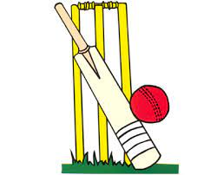
So, we eliminated Southpark from the cricket tournament. Mayespark happily made it to the semi-finals. We played against Wells Primary School and unfortunately, they eliminated us from the tournament. So we waited for our taxi, and he generously dropped us back to Mayespark
Primary School. We returned safely and happily although next time we will try to win the finals. We are all proud of our team-mates for the following wickets:

Spectacular preformance by Mayespark cricket team
A few children from year six were elected by Mr Darcy to have the opportunity to participate in a cricket tournament.
The elected team were Ibrahim (our team captain) Hashir, Fiza, Abdullah, Aima, Khadijah, Pardeep, Uzair, Omar and Umar.
Firstly, Mayespark played against SouthPark Primary School, they set the score to 53 runs. Mayespark fortunately scored 54 runs and won our first match. Secondly, we played against Bancroft Primary School. Unfortunately, we lost to 96 runs as Mayespark scored 40 runs. Surprisingly a few schools did not arrive so again we played Southpark Primary School. Also, they scored 59 runs while Mayespark scored 78 runs successfully.

Name of Player | Number of Wickets Taken
Ibrahim | 3
Hashir | 3
Abdullah | 2
Aima | 2
Khadijah | 3
Pardeep | 1
Uzair | 1
Next cricket tournament is in March sometime. All thanks to Mr Darcy who took us to the tournament and Mrs Haroon.

