National Child Measurement Programme Team
Redbridge 0-19 Children’s Services
Hainault Health Centre
Manford Way
Chigwell
Essex
IG7 4DF

Telephone: 0300 300 1579 Option 2

December 2024

Dear Parent/Guardian

Height and weight checks for children in reception and year 6
Every year in England, school children in reception and year 6 have their height and weight checked at school as part of the National Child Measurement Programme (NCMP). Height and weight measurements are used to calculate weight status. We collect this information to build a picture of how children are growing, to help plan better health and leisure services for families.
In most areas, parents receive their child’s measurement data, because this can be useful information about their child’s growth and provides an opportunity to offer support to parents where required. Your child’s class will take part in this year’s programme.
The programme will be delivered in a safe way, in line with the school and local authority’s safety control measures and national guidance for schools and healthcare.
The checks are carried out by registered school nurses or trained health and care providers. Children are measured fully clothed, except for their coats and shoes, in a private space away from other pupils.
Please the see the NCMP process animation link for further information: https://www.youtube.com/watch?v=7W771420z9g

Maintaining the wellbeing of children in the NCMP
The wellbeing of children and families is very important. Measurements are conducted in a sensitive way, in private and away from other children. Research is ongoing to ensure this continues to be done in a supportive way.
Individual results are not shared with your child or their school. The weight and height information is shared only with you, via a parent feedback letter. It is your choice to share or not share the information with your child.
If you are concerned about your child’s growth, weight, body image or eating patterns, seek further support from a school nurse or GP.

The information we collect and what it is used for

Your child's data
Your child’s height, weight, date of measurement, sex and date of birth are used to calculate your child’s weight category (also known as body mass index, or BMI).
Your child’s name, date of birth and NHS Number are used to link your child’s measurements in reception and year 6.
Other data sets held by NHS England and Department of Health and Social Care (DHSC) may also be linked to allow information from health and education records to be added, where lawful to do so. This helps understand how and why the weight of children is changing, and how this affects children’s health and education and how the care children receive can be improved. These other data sets may include your child’s health data relating to:
- their birth
- hospital care (including time in hospital and out-patient appointments and diagnosis of medical conditions)
- mental health
- social care

- primary care (including all healthcare outside of hospital, such as GP and dental appointments)
- public health (including data relating to preventing ill health, such as immunisation records)
- records for when and the reason why people pass away
- medical conditions, such as cancer and diabetes
- health, lifestyle and wellbeing surveys that your child has participated in
Your child’s ethnicity and address are used to help understand some of the reasons for the difference and changes in child weight across England.

Why we need your contact details
We need your address to send you your child’s feedback letter. This will include your child’s measurements together with information about healthy eating, being active and related activities available in your area.
We need your email address and phone number because we may:
- contact you by email or phone to discuss your child’s feedback
- offer you further support following your child’s height and weight measurement

How the data is used
All the data collected is also used for research and planning to improve health, care and services.
All this information is treated confidentially and held securely. No individual measurements will be given to school staff or other children.
The information collected from all schools in the area will be gathered together and held securely by NHS NELFT. We will store your child’s information as part of the local child health record on the NHS’s child health information database and may share it with the child's GP.

We will send all the information collected about your child to NHS England. NHS England is responsible for collecting data and information about health and care so that it can be used to monitor and improve the care provided to people across England.
The information collected about your child will also be shared by NHS England with the Office for Health Improvement and Disparities (OHID) which is part of DHSC but in a de-personalised form only. This means OHID will not be able to identify your child.
Both NHS England and OHID will use the information from the NCMP to better understand numbers and trends in child weight and BMI. This helps to plan services to support healthy lifestyles in your area. No information will ever be published by NHS England or OHID that identifies your child. NHS England uses the data to produce National Child Measurement Programme statistics reports showing trends at national and local level.
De-personalised information from the NCMP may also be shared by NHS England with other organisations, such as universities. This is to help improve health, care and services through research and planning. This information cannot be used to identify your child. NHS England only ever shares information for research through formal assurance and approvals processes, seeking advice from experts as necessary.

Withdrawing your child from the National Child Measurement Programme
If you are happy for your child to be measured, you do not need to do anything.
If you do not want your child’s height and weight to be measured, or your child has a medical condition that affects their height or weight, please let us know using the contact details provided above and by writing to your child’s school marking the letter for the attention of the NCMP Team. Children will not be made to take part on the day if they do not want to.

Further information
You can find further information about the NCMP at The National Child Measurement Programme NHS webpage.
You can find information and fun ideas to help your kids stay healthy at the NHS Better Health: healthier families webpage Easy ways to eat well and move more.

Another way to help maintain a balanced diet and physical activity for your family is the NHS Healthy Steps email programme. Sign up for the 8-week Healthy Steps emails and you will be sent lots of low-cost easy tips, fun games, healthy swaps and tasty recipes on a budget. You can sign up to NHS Healthy Steps - Step this way webpage or scan the QR code:
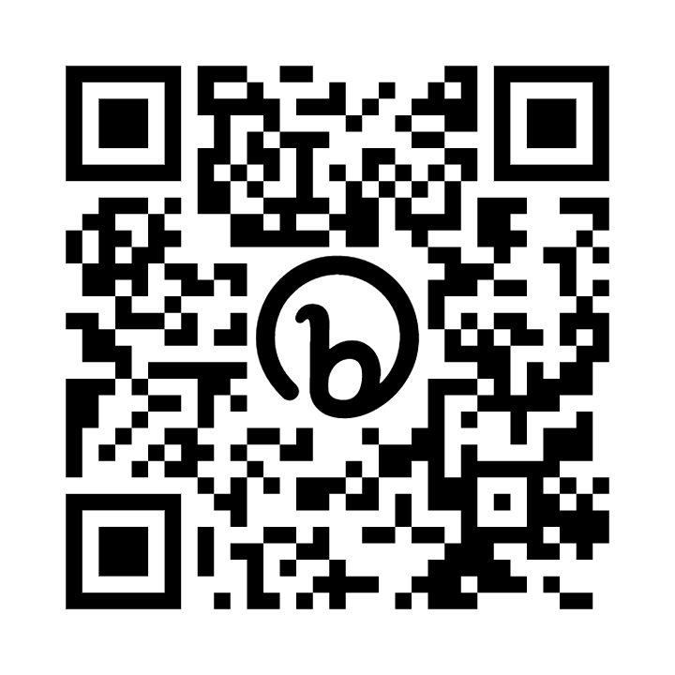
You can find information about how NHS England and DHSC collect and use information at:
- NHS England's How we look after your health and care information webpage
- the DHSC Personal information charter webpage
You can find information about the organisations NHS England has shared information from the NCMP at NHS England's National Child Measurement Programme webpage.
Yours faithfully,
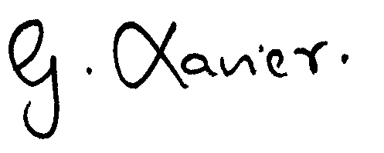
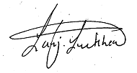

Gladys Xavier Sanjiv Luckhea
Director of Public Health Redbridge Redbridge Integrated Care Director

Further information for parents

How your child’s data is collected and processed as part of the National Child Measurement Programme
Local authorities have a legal duty to collect the National Child Measurement Programme (NCMP) data. They do this by following guidance from the Office for Health Improvement and Disparities (OHID), part of the Department of Health and Social Care.
Local authorities are responsible for making decisions on how the data is collected and making sure it is protected. Local NCMP service providers are contracted to do the measurements. This might be through the school nursing team or a local healthcare provider. The team collecting the data enter it into the NCMP IT system, which is provided by NHS England. The data may also be entered into a local child health information system.
Your local authority is responsible for sending the data to NHS England. NHS England and OHID are jointly responsible for the data held at a national level. Your local authority is responsible for the data held locally.

