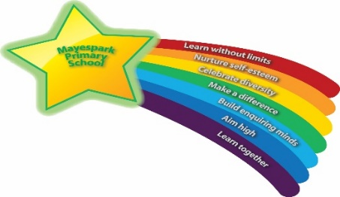

At Mayespark, we greatly value the power of reading. Not only does it transport our children and adults to magical lands full of fascinating creatures and adventures but it also has a positive impact on creativity, imagination, spelling, grammar, vocabulary and wellbeing. It is so important that we dedicate daily curriculum time to it as a non-negotiable for every class in the school.

School, however, is not the only place in which our children should be encouraged to read. We have had a long commitment to reading records across the school and ask that these are completed daily at home. Our expectations (in the table below) are that **every child** **reads** **every night** at home and are listened to by an adult as often as possible.

In order to support as much as we can, we have collated a list of suggested reads for your child. Why not see how many of these texts your child can read this year? They are available at book shops and libraries in our local area! Perhaps your child could tick the ones they have read to keep a record or even write a book review to encourage their peers to read the book.

|  |  |
| --- | --- |
|  | **Year 5&6** |
| **Reading to your child** | It is still important that parents/carers read to older children. This may involve reading together and talking about non-fiction texts. For example, a newspaper article or an information book about a topic they are interested in. |
| **Hearing your child read** | Children are to read at home at least 6 days a week for at least 30 minutes a day. Once your child has been told by their teacher they are an ‘Independent Reader’, they may prefer to read their reading book on their own. |
| **Signing your child’s reading record** | Sign and date your child’s reading record each day they read. Independent Readers can record in their reading record themselves and parents are expected to sign it once a week. |
| **Changing books** | Children can change their reading book whenever they need to. Class teachers will check reading records daily and will sign / comment in your child’s reading record once every three weeks. |

Enjoy the books and let us know what you think of them!

**As we strive to improve reading standards, please consider supporting us by purchasing a reading book for your child’s reading corner. We have created a wishlist of books for different year groups and would very much appreciate any donations! Every book donated will have a presentation sticker stuck on the inside cover naming the donor. You can explore our wishlists via the following links**:

EYFS: [Mayespark Wishlist Years Early Years | Waterstones](https://www.waterstones.com/booklist/1342716/claire-ige-mayespark-wishlist-years-early-years)

Year 1 & 2: [Mayespark Wishlist Years 1&2 | Waterstones](https://www.waterstones.com/booklist/1342713/claire-ige-mayespark-wishlist-years-1and2)

Year 3 & 4: [Mayespark Wishlist Year 3&4 | Waterstones](https://www.waterstones.com/booklist/1175628/claire-ige-mayespark-wishlist-year-3and4)

Year 5 & 6: Mayespark Wishlist Year 5 & 6 | Waterstones