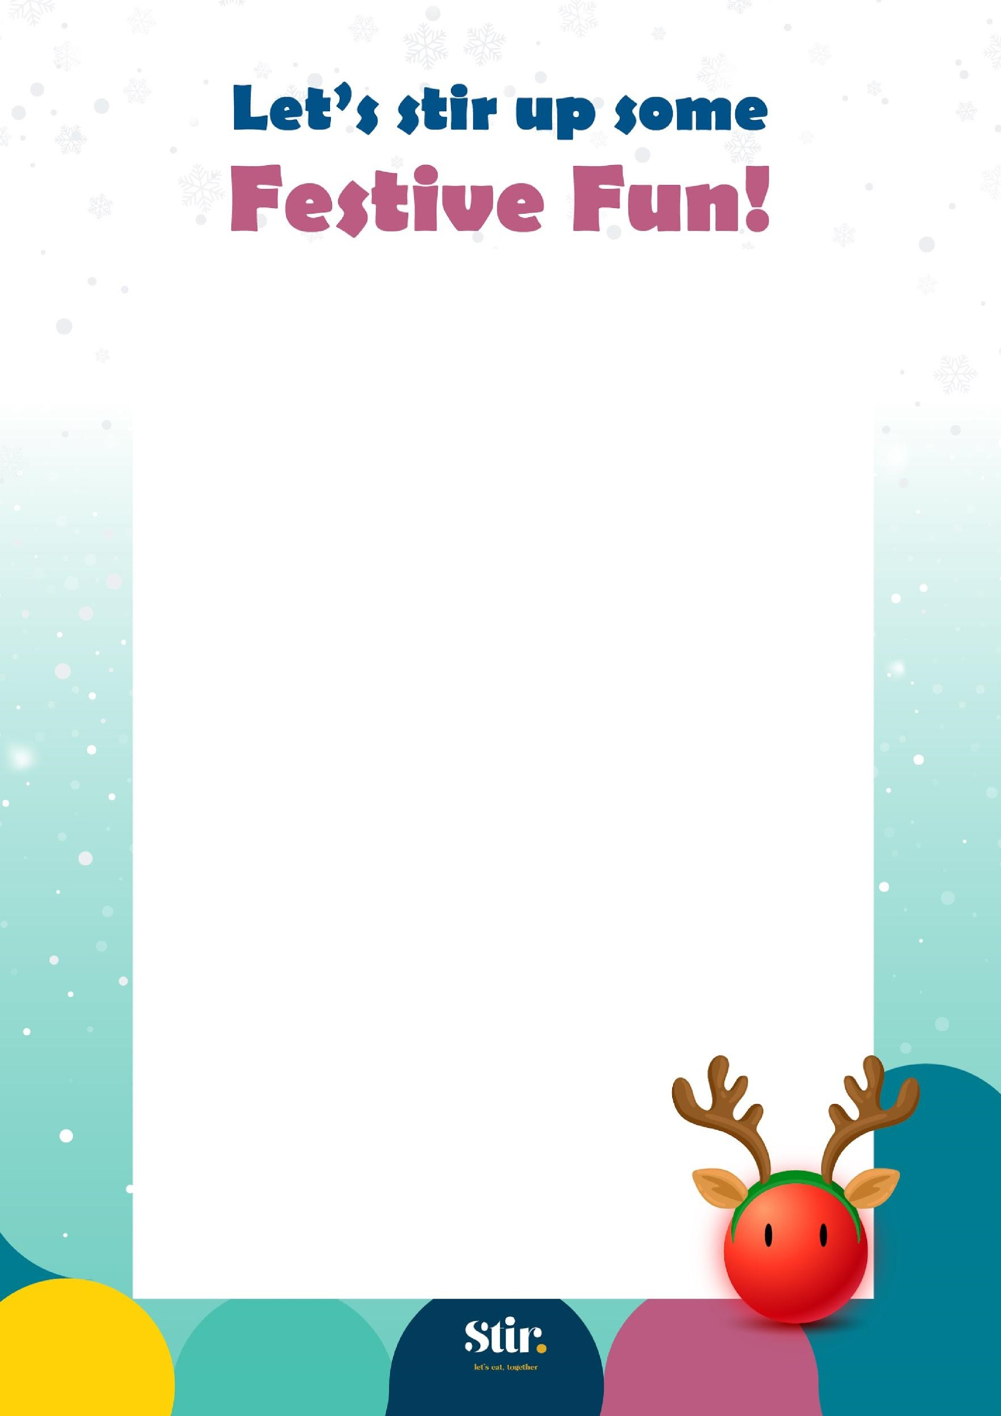

Christmas Lunch

**Main Event**

**T**

**raditional**

**Glazed British Turkey Breast**

Crispy Roasted Potatoes, Stuffing, Carrots,

Sprouts & Gravy.

Halal and Non-Halal Available

---

**Parsnip & Apple Wellington**

Crispy Roasted Potatoes, Stuffing, Carrots,

Sprouts & Gravy.

---

**Tomato Pasta**

with a Sprinkling of Cheddar Cheese

**Dessert**

Festive Chocolate

Shortbreads



Thursday 19th December

The most magical time

of the year is here and

we're excited to invite

you to our festive lunch!

Join us!