Contents
Our school vision | Page 2/3
Introduction | Page 3
People you need to know | Page 4
Organisation | Page 5
Attendance and illness | Page 5
Uniform for Reception children | Page 6/7
Lunch, food and snacks | Page 7/8
Induction | Page 8/9
Teaching and learning in Reception | Page 9/10
An example of a typical Reception day | Page 11
Progress | Page 12
Home learning | Page 13
Getting ready for school | Page 14

Our School Vision
Mayespark is a school where all staff work together to ensure that every child is inspired to achieve their best.
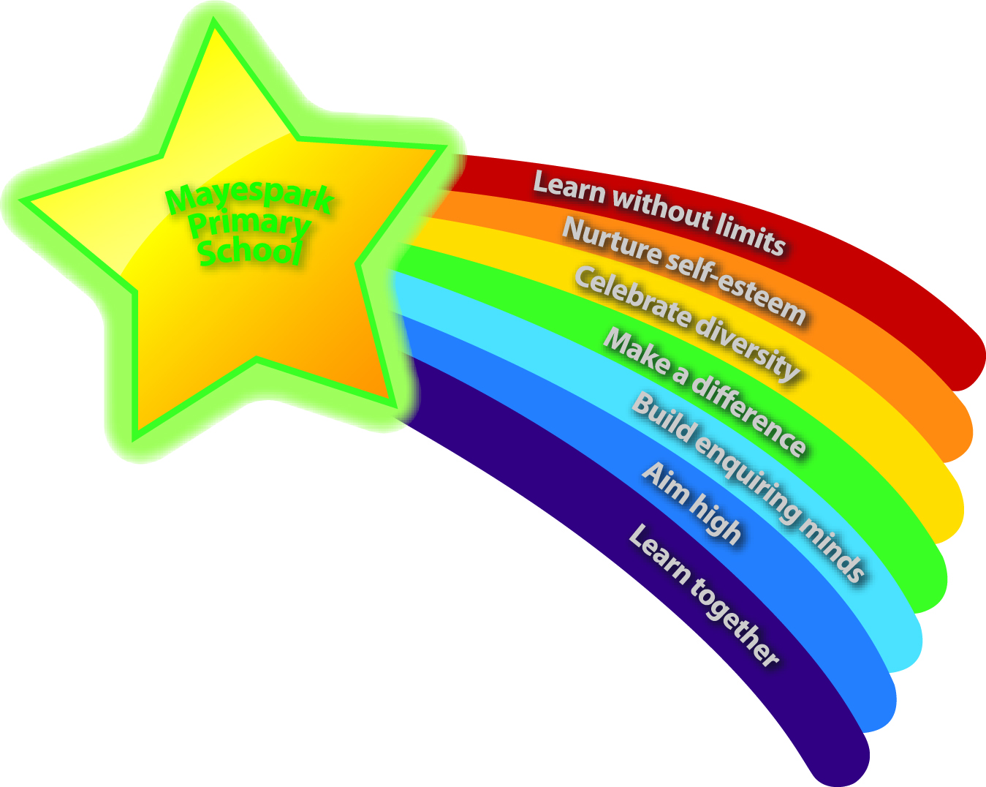
Children look forward to coming to school and take pride in their learning environment
Children develop enquiring minds and are provided with memorable educational experiences
Children achieve high standards through an exciting and stimulating curriculum
Children develop high self-esteem and confidence and become self-motivated independent learners
Children have positive attitudes, good behaviour and an understanding of what is right and wrong
Children learn within a safe, supportive, inclusive and caring environment
Children learn to respect each other’s religious and cultural values and celebrate the diversity of our community
Children believe and understand how they can make a difference in the world

Introduction
Welcome to Mayespark Primary School.
We believe that the key to a good start and a successful, happy school career is a good trusting relationship between our staff and our families. With this in mind, we aim to give you as much information about us as possible and to provide you with opportunities to tell us about your children, before term starts in September.
Along with this booklet, you will also receive a school prospectus. You can also access information about uniform, attendance, behaviour policies and much more on our website at
www.mayesparkprimaryschool.org.uk
We hope you find this information useful and would appreciate any feedback on this booklet and the induction process.

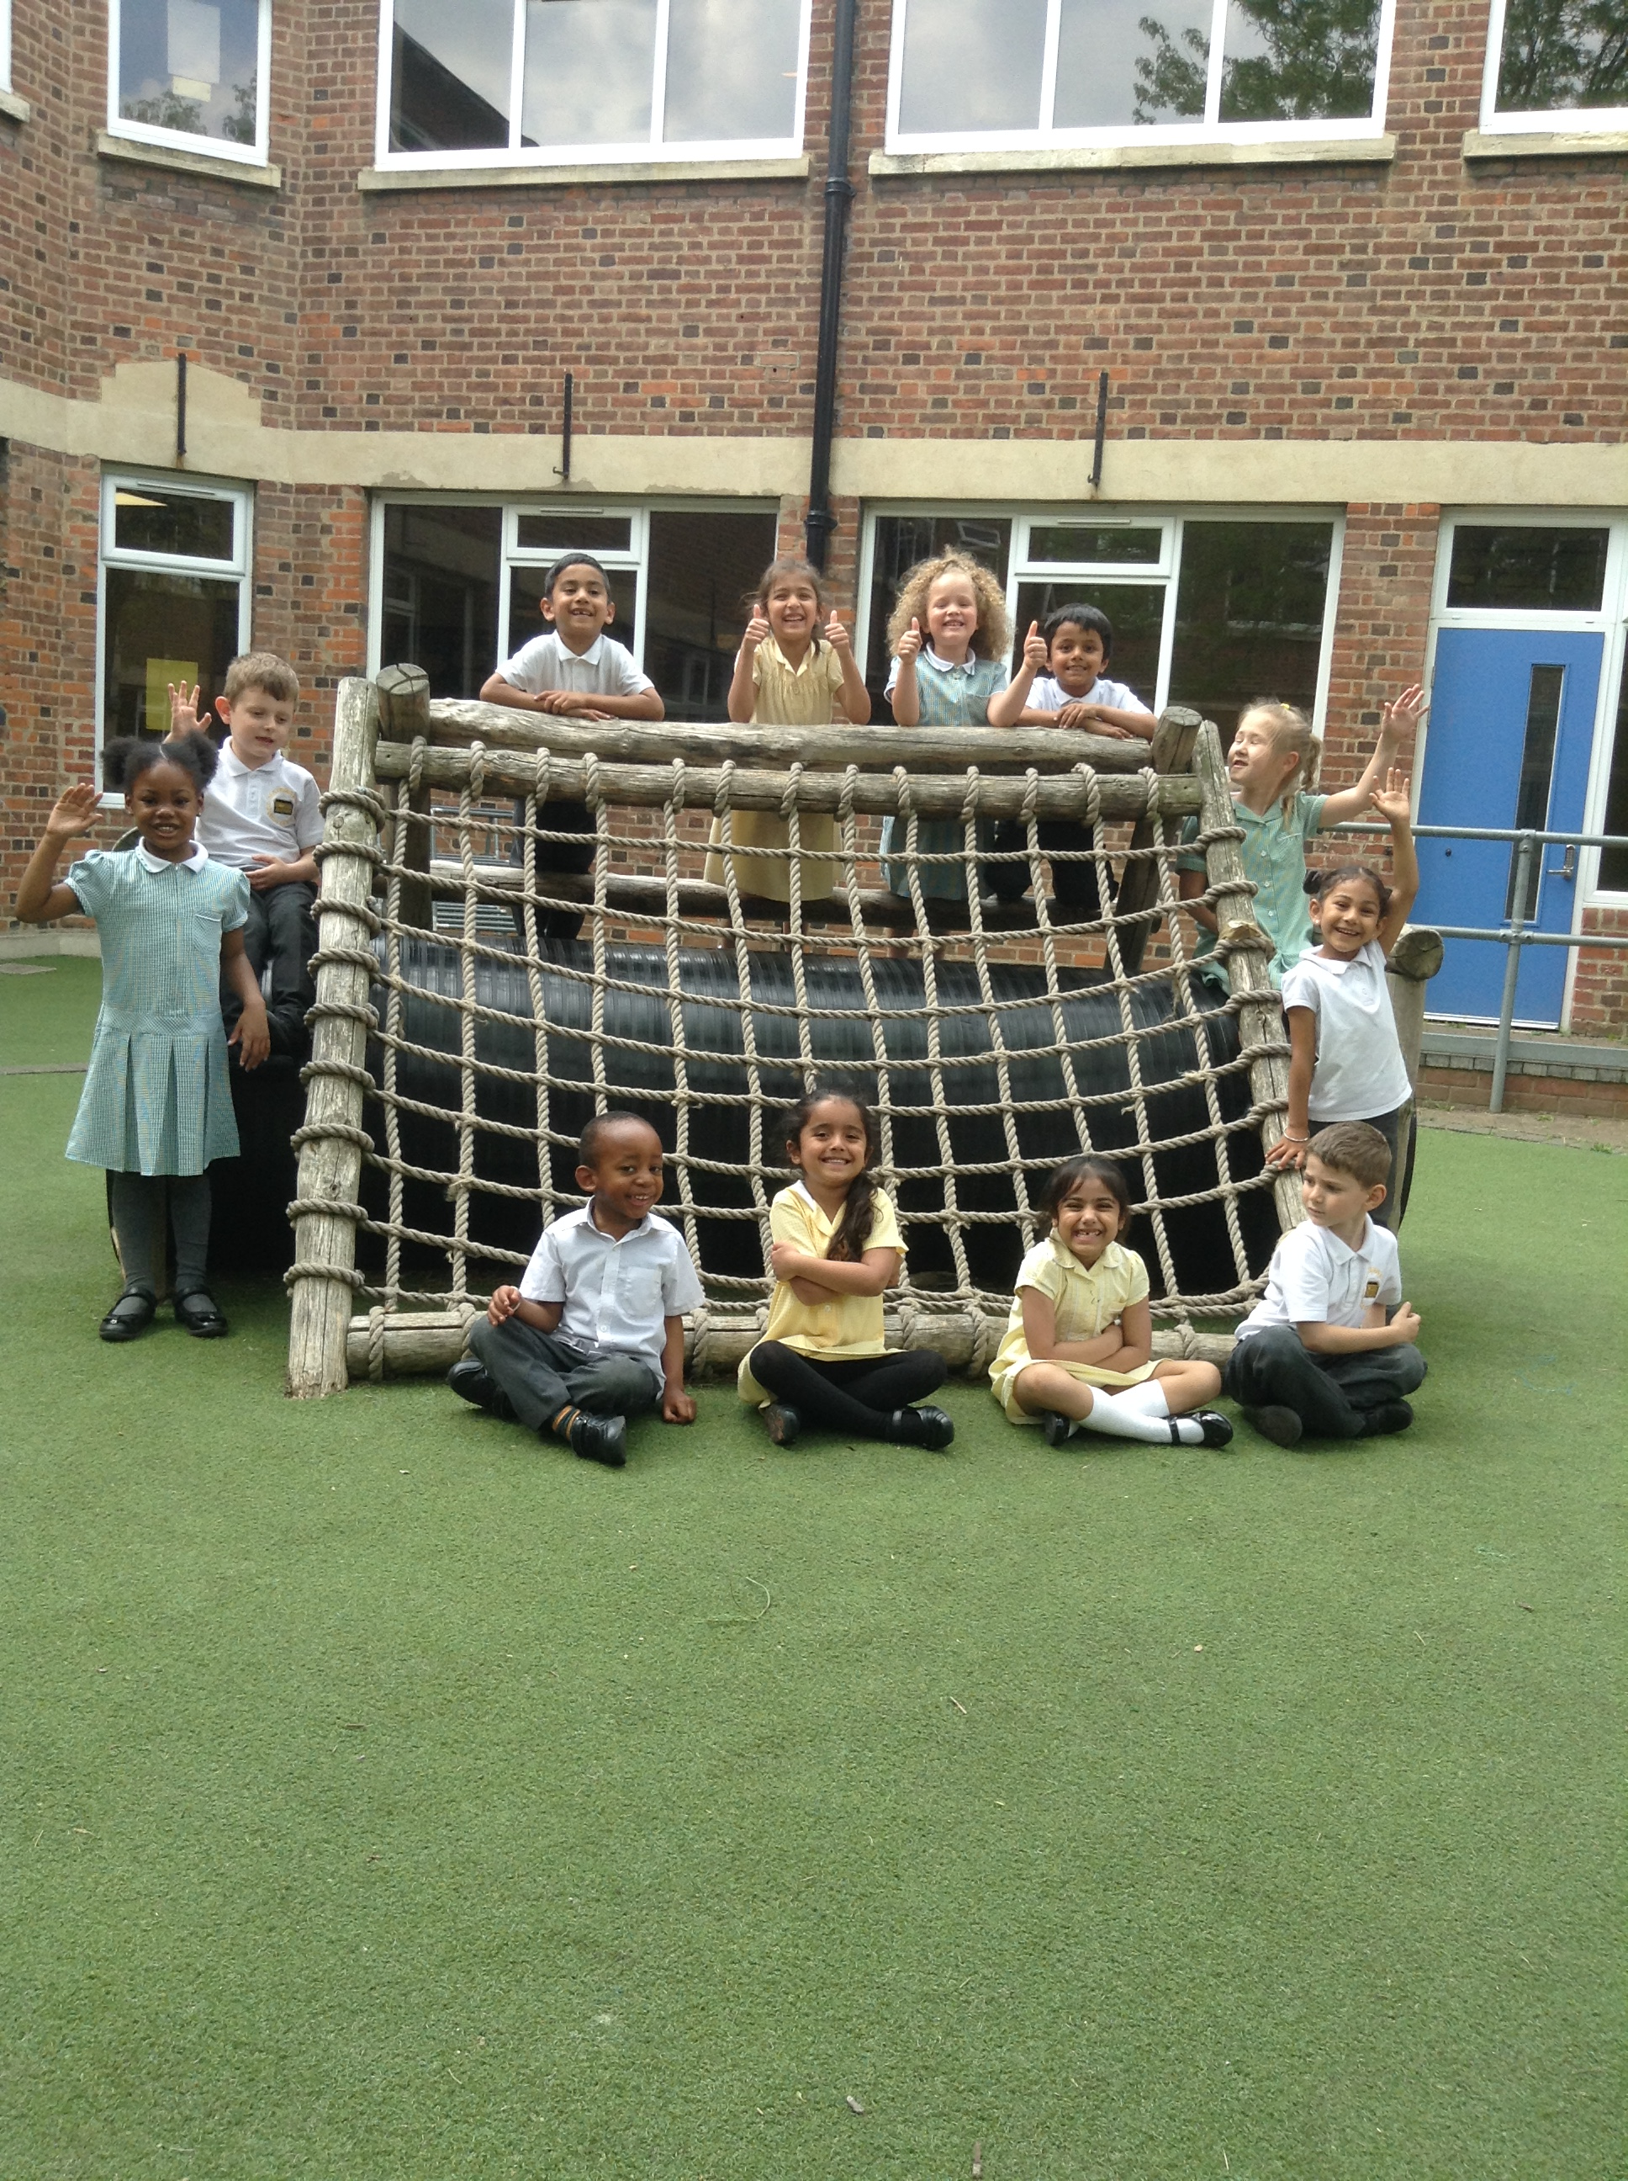

People you need to know
Reception Class Teachers
Miss Nour  Early Years Leader | Mrs Bhogal  Class Teacher | Miss Ahmed  Class Teacher
Each class also has a qualified nursery nurse
PPA Teachers
All class teachers are entitled to half a day each week for planning, preparation and assessment (PPA). The school’s PPA team cover these sessions. Nursery nurses remain with their usual classes during this time.

Senior Leaders
Ms Davies
Head Teacher

Mrs Jones
Deputy Head Teacher

Mr Muquith  Assistant Head Teacher | Mr Radmore  Assistant Head Teacher | Mrs Ige  Assistant Head Teacher

School contact number: 0208 599 2263
School email: admin.mayespark@redbridge.gov.uk
Organisation
At Mayespark we have three Reception classes. Each class has its own teacher and nursery nurse and up to 30 children. Each class is based in its own classroom, though children and staff may move between the classrooms to take part in different activities. The three classes also share a large outdoor area, which we call our Learning Garden.
The classes open in September and children stay in the same class until the end of the school year in July. All the children in Reception will celebrate their 5th birthday between 1st September 2022 and 31st August 2023. In September 2023 they will move to Year One.
Reception classes run from 9:00am - 3:15pm with a break for lunch from 11:40am - 12:40pm. Teachers welcome children and parents at 8:55am and the pupils enter straight into the classroom. This is a good time to pass on any messages or ask quick questions. Teachers dismiss classes from their classroom doors at 3:15pm and are usually available for a brief discussion when most of the children have left. Teachers are always happy to make appointments with you, if you need to discuss anything at length.
Attendance and Illness
It is vital to your child’s development and progress that they come to school every day. However, if your child is ill (not including coughs and colds), you should keep them at home and inform the office (0208 599 2263 option 2) of the reason for their absence before 9:00am.
In the case of sickness or diarrhoea, children must be kept at home until they have been clear for 24 hours.
The school will not authorise absence for holidays, birthdays or special events during term time and fines may be imposed. Our attendance staff and the Educational Welfare Officer keep a close eye on attendance and lateness and will contact families whose attendance is poor. The Educational Welfare Service prosecutes parents of children with persistent absence, which may result in a fine or a court appearance and a criminal record for parents.
School Uniform

Boys | Girls
- Plain grey trousers or shorts  - White polo top or shirt  - Green jumper (preferably with MPS logo)  - Black shoes or trainers (plain and with black laces)  - Black, grey or white socks  - Green, black or white hair accessories in school colours  - MPS bookbag | - Plain grey trousers, shorts, skirt, pinafore or shalwar kameez  - White polo top or shirt  - Green and white checked dress (can be worn with plain white trousers)  - Green cardigan or jumper (preferably with MPS logo)  - Black shoes or trainers (plain and with black laces)  - Black, grey or white socks or tights (no leggings)  - Plain black or white religious head wear  - Green, black or white hair accessories  - MPS bookbag
Not included in our school uniform:  - Leggings  - Nail polish  - Jewellery (small stud earrings are permitted)  - Open toed sandals, heeled shoes or high boots  - Any item of clothing with logos, slogans or patterns (excluding MPS logo)  - Any bags other than an MPS bookbag or a simple drawstring bag for PE kit | PE Kit:  - Plain white crew neck t-shirt  - Black shorts  - Black leggings  - Plain black jumper  - Plain black tracksuit or jogging bottoms for outdoors only  - Black plimsolls or plain black trainers  - Drawstring bag for PE kit

In addition to the above, we ask that you provide your child with a named water bottle. Children having packed lunch will be required to bring their lunch in a named lunch box or bag.
Please remember to clearly label all items with your child’s full name. There are up to 90 children in the Reception classes who are a similar size, wearing the same uniform, so items are easily mixed up and can be difficult to trace if lost. Lost property is stored in the lift up box, which can be accessed from the back playground. Please also remember that children play outside every day. In cold weather they need hats, scarves and gloves and in hot weather they need sunhats and sun cream (please apply this before children come to school).
Children in Reception take part in a range of physical play activities outside their allocated PE lessons, so please make sure they are wearing sensible shoes. Please expect your child to get dirty! The Reception curriculum is filled with physical and creative activities involving lots of digging, painting, model making and climbing. Products used are bought from reputable educational suppliers and can usually be removed from clothing by soaking before washing. School uniform can be purchased online via a secure website called Brigade: www.brigadeuniformdirect.uk.com using credit or debit cards, or in person from Rupens Schoolwear: 98-100 Meads Lane, Ilford, Essex IG3 8QN, 0208 590 3734. Our office staff are happy to help if you need it.

Lunch, Food and Snacks

School dinner menus are sent out at the beginning of every term, and include vegetarian and halal choices every day. Reception children wear badges stating if they require vegetarian or halal options, or if they have any allergies, which are checked before they are served. All Reception children are now entitled to Universal Infant Free School Meals (UFSM). You must apply for this provision online at www.redbridge.gov.uk
Packed lunches should be sent to school in a clearly labelled lunch bag or box. As a healthy school, we do not allow children to eat sweets or fizzy drinks. A healthy packed lunch is essential to your child’s wellbeing and may include: a sandwich, roti or portion of rice/pasta, a piece of fruit or a yoghurt. Children are only allowed to bring in a treat such as a biscuit, cake or crisps, once a week on a Wednesday. We are very strict regarding this matter; on no other day are children permitted to eat unhealthy treats. Please note, at Mayespark we have children with severe nut allergies. Therefore, we are a nut free school and under no circumstances should children have food containing nuts in their packed lunch. Any uneaten food will be left in your child’s lunchbox, so you can monitor their eating. A mix of midday assistants and Reception staff, do their very best to encourage all children to eat by supervising lunches. If a child is having problems eating, we will let you know. You will be asked about your child’s diet and eating habits on your Induction Day and any information you give us will be recorded on your child’s entry profile and on their school dinner badge.

Snacks - Fruit is provided daily by the Government Fruit Scheme, please do not send in any other snacks. All Reception classrooms have drinking water and cups available, so children are free to pour themselves a drink whenever they want to.

Cooking - Cooking activities are sometimes planned to support learning in various areas of the curriculum. We always consider the dietary needs of our children and plan to use ingredients suitable for all our children.
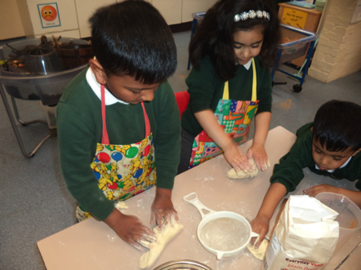

Induction

Starting full time school is a big milestone, which can be very exciting and also a little worrying. We believe that a positive, trusting relationship between parents/carers and staff is essential to children’s wellbeing, happiness and progress. We have put a great deal of thought into organising the induction and settling period so that parents and children are well prepared for starting school and have the best possible start. The process is outlined below:

Wednesday 15th June 2021  9:15 am | New Parents’ Meeting  Key staff will present information about Mayespark School and how our Reception classes work. You will be given an induction pack, including a parents’ handbook, school prospectus, and details of your child’s class and start date. There will be plenty of opportunities to ask questions.
September 2022  Monday 5th  Tuesday 6th  Wednesday 7th | Induction Days  All parents/carers are expected to bring their children to explore their new class. Parents/carers will have a discussion with the class teacher or nursery nurse about their child’s experiences, needs and interests. You will be given a day, which we require you to attend. During your visit you can see our Learning Garden and you may stay and play for as long as you wish. Parents should report to the school office and wait to be escorted to their child’s class.
Thursday 8th September 2022 | Summer and Spring born children start  Thursday 8th September (morning only) 8:40am - 11:00am Friday 9th September (morning and lunch) 8:40am - 1:00pm Monday 12th September (first full day) 8:40am - 3:15pm
Tuesday 13th September 2022 | Spring born and Autumn children start  Tuesday 13th September (morning only) 8:40am - 11.00am Wednesday 14th September (morning and lunch) 8:40am - 1:00pm Thursday 15th September (first full day) 8:40am - 3:15pm

Teaching and Learning in Reception
We believe that children learn best when they feel relaxed and confident and are having fun. Our Reception classrooms and Learning Garden are set up to enable children to learn in a variety of ways. Sometimes children’s learning is lead directly by an adult in a planned focus activity; the adult may work with the whole class, a small group or individual children on activities planned to meet specific learning intentions.
Sometimes children will be working independently, within areas set up to develop different skills. For example practising writing at the writing table, investigating magnets at the discovery table, sharing tools and equipment at the making table or exploring adult roles (making dinner or looking after a baby etc) in the role-play area. Adults may model the skills they wish to see children develop in their free play, or ask challenging questions to help children extend their ideas.
For large parts of the day, we operate a child initiated learning system, where children can decide whether they wish to play in their classrooms or outside in the Learning Garden. The classroom and Learning Garden are set up to promote learning in all areas of the curriculum.
Indoor and outdoor activities include:
maths areas, writing areas, discovery areas, book corners, role-play areas, iPad stands, sand and water trays, play-doh tables, creative areas, small world areas, large physical play (climbing frame, bikes and balancing equipment), small physical play (hoops, bean bags, bats and balls) and construction areas.
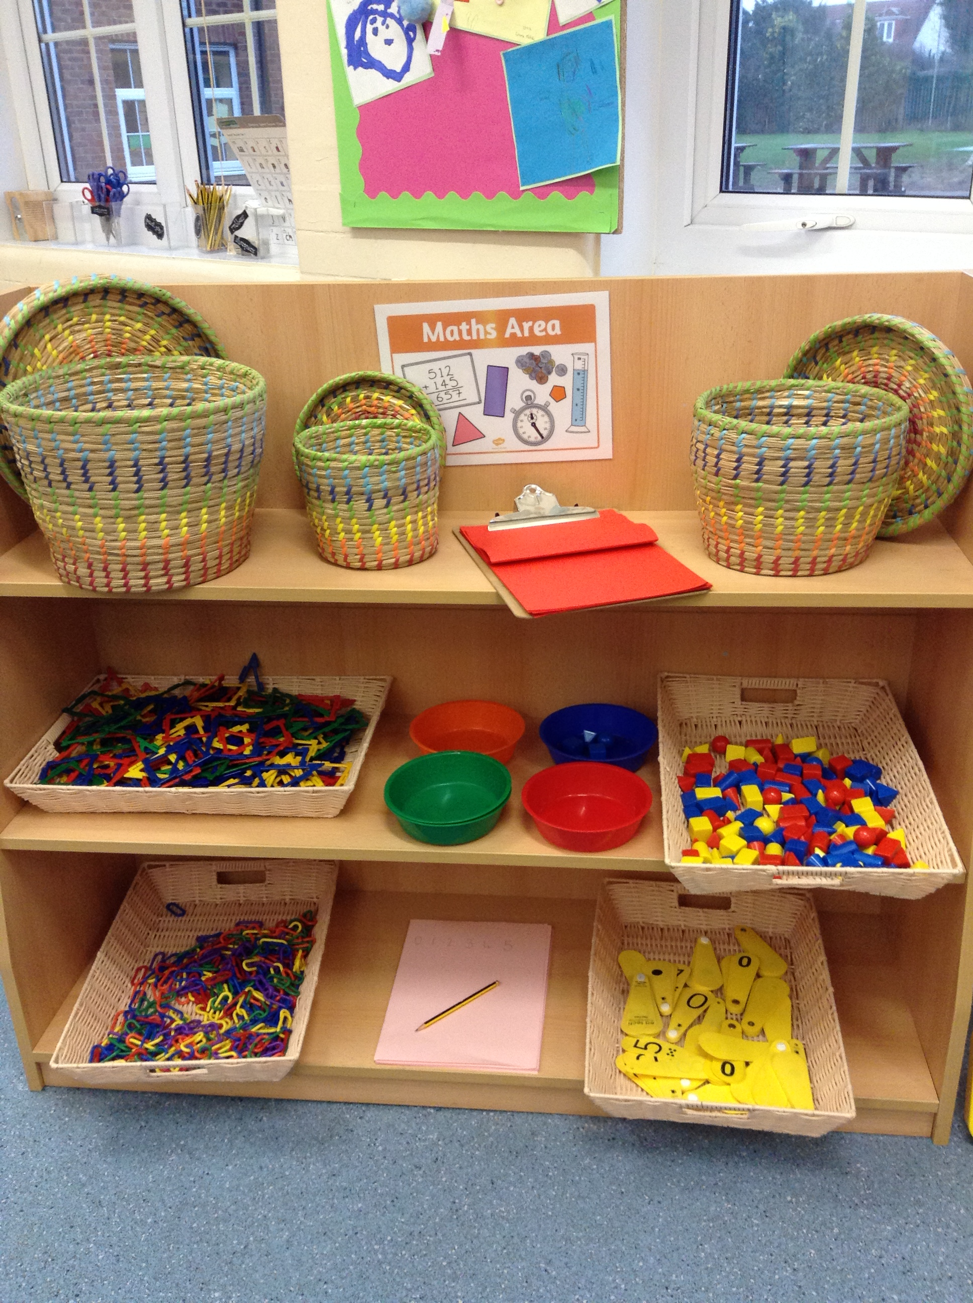
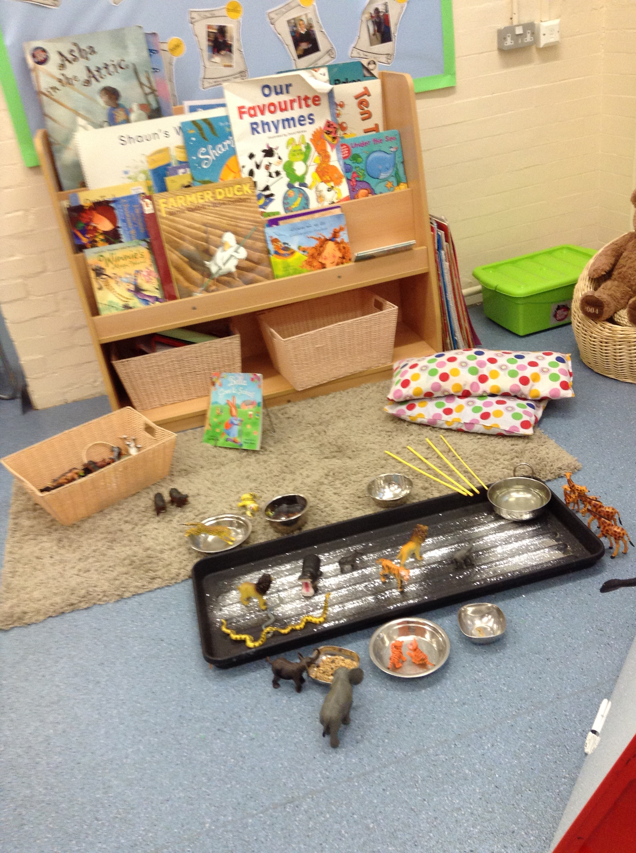
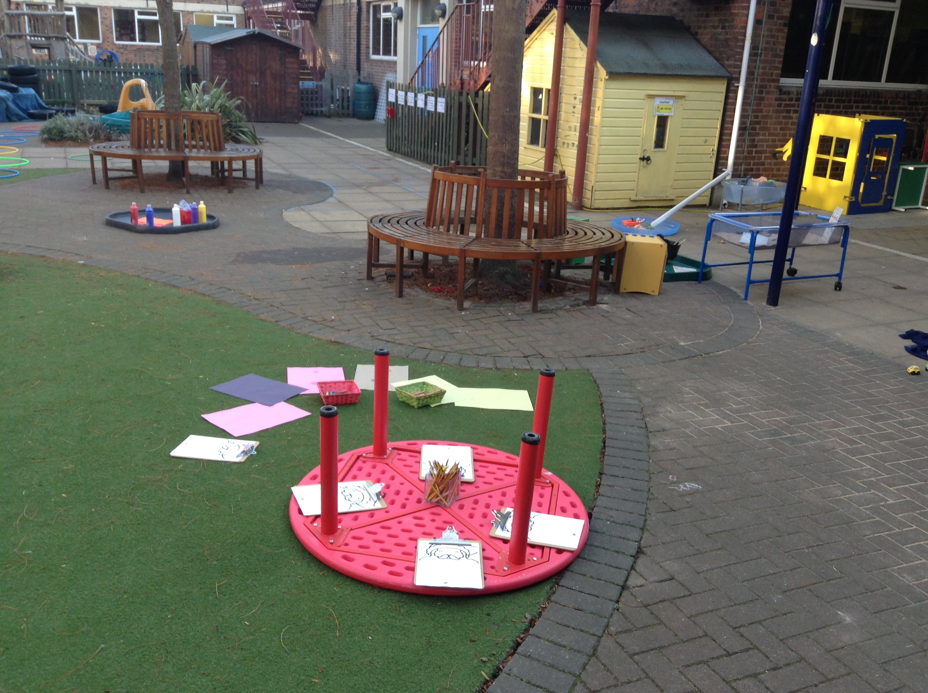

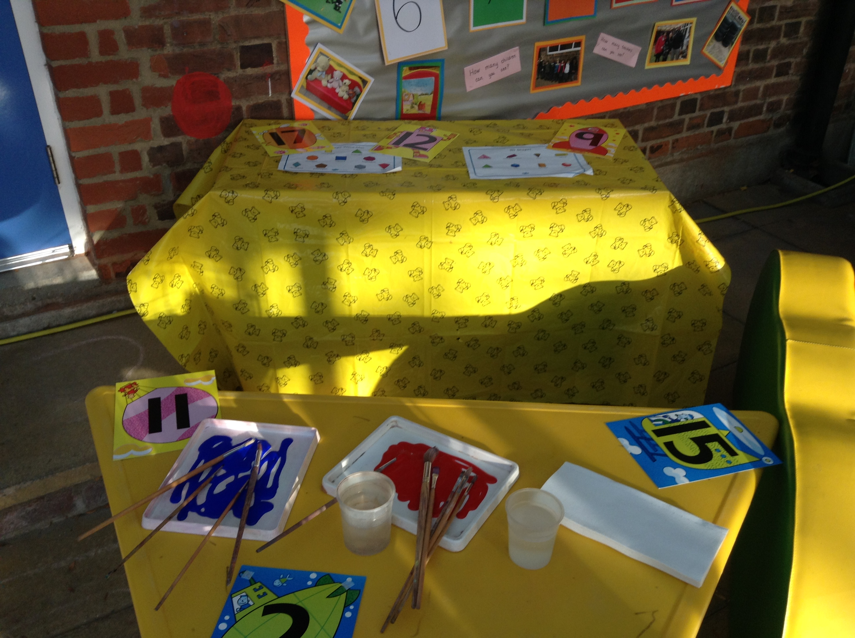
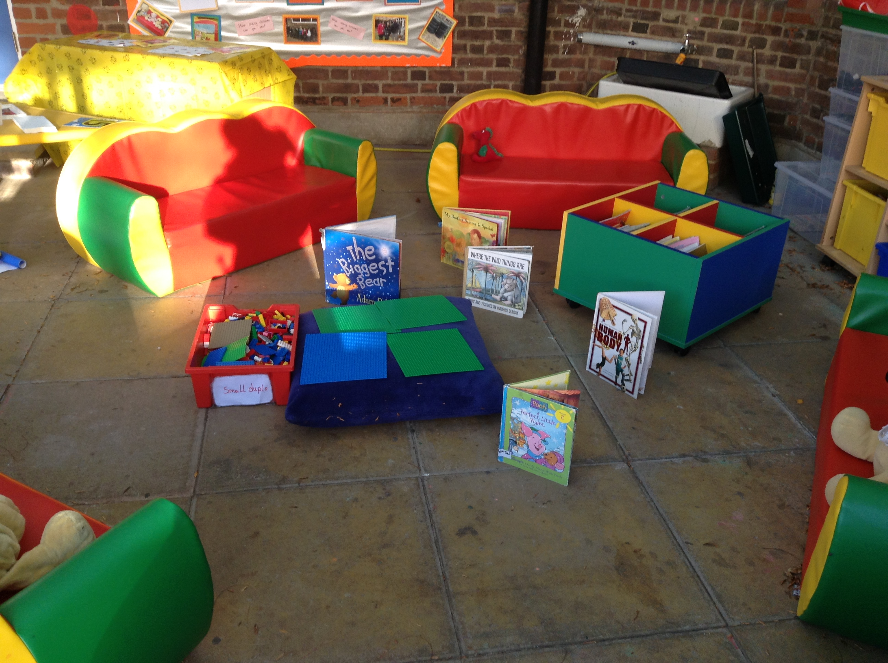

Our curriculum is carefully planned using the most recent government guidelines, this is called the statutory framework for the early years foundation stage. In the early years curriculum there are seven areas of learning including three prime areas and four specific areas, through which the prime areas are developed and applied.
3 Prime Areas of Learning
Personal, Social and Emotional Development:
- self-regulation
- managing self
- building relationships

Physical Development:
- gross motor skills
- fine motor skills

Communication and Language:
- listening, attention and understanding
- speaking

4 Specific Areas of Learning
Literacy:
- comprehension
- word reading
- writing

Mathematics:
- number
- numerical patterns

Understanding of the World:
- past and present
- people culture and communities
- the natural world

Expressive Arts and Design:
- creating with materials
- being imaginative and expressive

The framework also places a strong emphasis on children developing effective learning skills
- Playing and Exploring (engagement)
Finding out and exploring, playing with what they know, being willing to ‘have a go’
- Active Learning (motivation)
Being involved and concentrating, persevering, enjoying achieving what they set out to do
- Creating and Thinking Critically (thinking)
Having their own ideas, making links, choosing ways to do things

Partnership with parents
It is important for parents and early years settings to have a strong and respectful partnership. This sets the scene for children to thrive in the learning environment. Parents will be given clear and regular information about their children’s progress along with ideas and strategies to support their learning at home.
Parents will also be invited to come into their children’s classroom to take part in read together sessions, phonics sessions and communication and language activities.
Throughout the academic term, we will be sending information about the curriculum to inform what the children will be learning at school along with ideas to support their home learning.

Our activities are planned around topics that change every half term and they vary from year to year.
Some of our topics are:

- All about me
- Celebrations
- Light and Dark

- Animals
- Where do we live?
- Seaside

To enhance our children’s learning, we plan educational visits each year, providing a different learning experience. Any visits outside school will be planned according to the requirements of the school’s Educational Visits Policy. Teachers will make a pre-visit inspection of the venue and detailed risk assessments will be written.
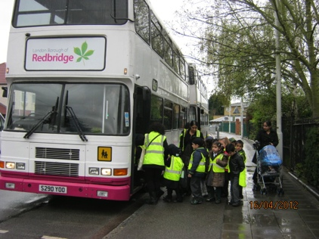

An example of a typical Reception day

This is an example of a day in Reception, this will change over the course of the year to suit the needs of the children.
8:40am | Teachers greet children and parents and children enter straight into the classroom. This is a good time to pass on any messages or ask quick questions. As children come into class, their reading record book is collected and they hand up their coat on their peg.
8:45am | Register and monitoring reading records (at 8:45am classroom doors are closed and any late children must be taken to the office). Daily routines are completed (writing names and counting how many children are present).
9:00am | Maths - Children sit down together as a class to work on practical maths activities, including counting, measuring, data handling, time, positional and directional language. This session involves a mixture of whole class teaching, partner and individual activities.
9:55am | Read Write Inc - This is our daily phonics and reading session. At the beginning of the year this will be class based, but before the end of the autumn term children will be assessed and divided into 8 smaller groups. The programme is very tightly structured and children are assessed and re-grouped regularly to ensure that everyone is taught at the right level.
10:35am | Independent learning - Children are free to select from a range of activities in the classrooms or Learning Garden. During this time, children will take turns to work with adults on planned focus activities for example hearing individual children read.
11:40am | Lunch - Children eat their school dinner or packed lunch in the dining hall, supervised by midday assistants. When children have finished eating, they go out to play on the playground at the front of the school. This playtime is supervised by midday assistants and teaching assistants, who all wear pink hi-visibility jackets. There is also a first aider on duty. During the first few weeks in school, children will go to the lunch hall 10 minutes earlier with their class teacher, who will help to settle them into our lunch routines.
12:45pm | Class reading - Children practise early reading skills with the teacher.
1:15pm | Independent learning - Children are free to select from a range of activities in the classrooms or in the Learning Garden. During this time, children will take turns to work with adults on planned focus activities for example practising recognising numbers.
2:45pm | Story Time - A story is read to the class and songs are sung as they get ready to go home.
3:15pm | Home time - Parents/carers collect children from the classroom door.

Progress
Staff are constantly monitoring children’s progress through working alongside them on planned or self-chosen activities. Samples of work, observation notes and photos are collected as evidence of each child’s learning and stored in their ‘progress files’. Parents/carers are welcome to look at these files at any time and are welcome to contribute their own notes about children’s achievements and interests.
Parents and carers are formally invited to meet with class teachers in the autumn term to discuss how their son or daughter has settled into class and again in the spring term to discuss their progress. In February and July, you will receive a full written report on your child’s progress and will be invited into school to look through children’s books and to meet the teachers for the following year.
If at any time we are concerned that your child is not making enough progress or is not meeting age related expectations, we will invite you into school to discuss our strategies for addressing particular needs. This may involve meeting with the Inclusion Leader to adapt our provision for your child. Similarly, if you have any concerns, you can make an appointment to discuss these with us.

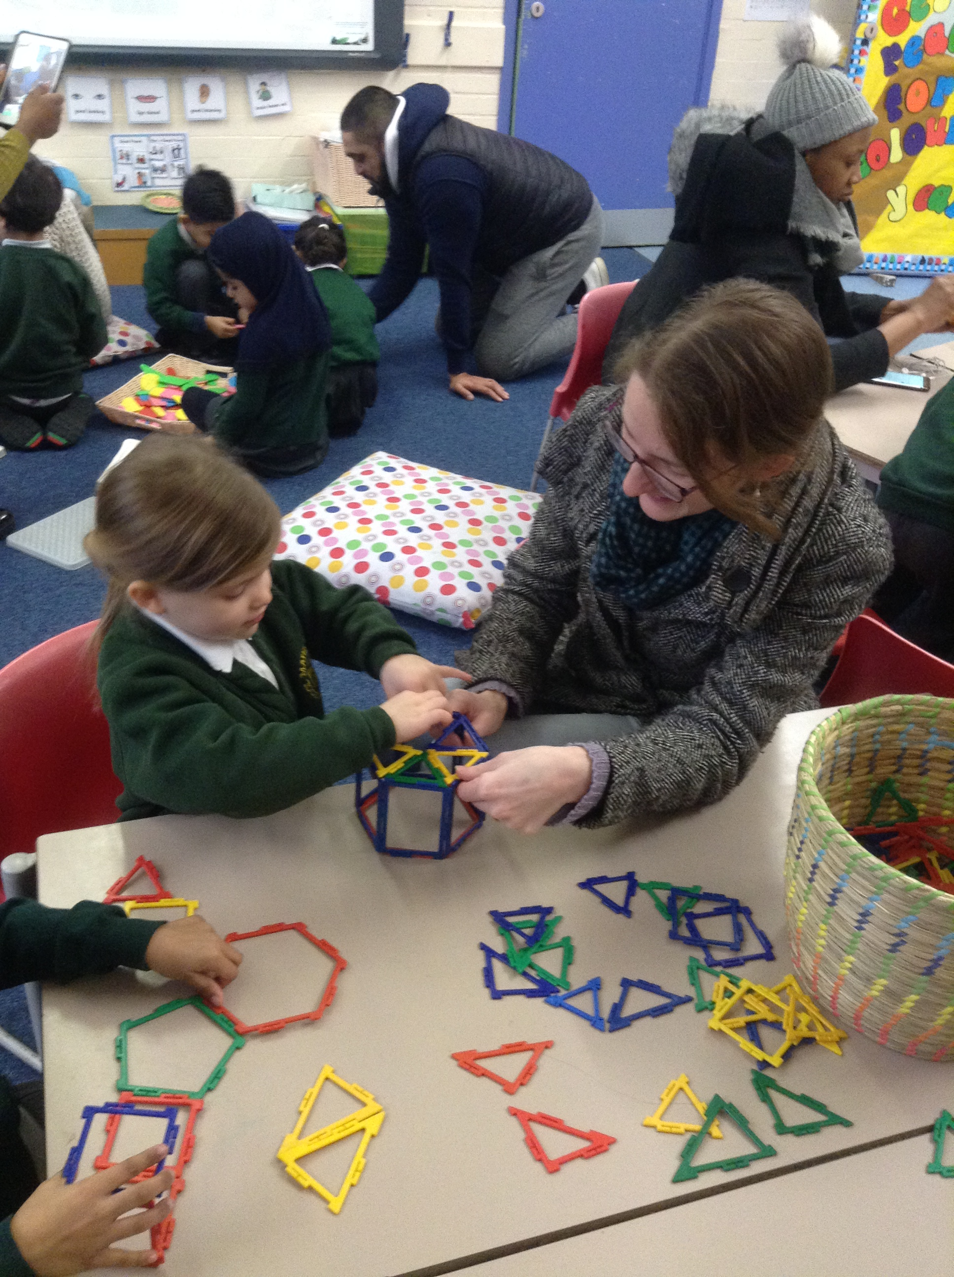

Home Learning
At Mayespark we believe that our children greatly benefit from a strong home school partnership. We consider parents and carers to have an important role to play in their child’s education and we fully support parents in doing so. You are able to find many home learning resources on our website and additional guidance will be sent home throughout the course of the year. If you ever require specific guidance regarding how to support your child’s learning at home, please do not hesitate to contact your child’s class teacher.
Reading
Reading plays an essential role in every child’s education. At Mayespark, we have very clear expectations regarding reading at home:

Reading to your child | Read different books to your child at least 6 days a week for at least 15 minutes.
Hearing your child read | Listen to your child read at least 6 days a week. Talk about what they have read referring to the comprehension questions in your child’s reading record.
Signing your child’s reading record | Sign and date your child’s reading record each day they read.
Changing books | School books will be changed at least weekly and a school adult will sign your child’s reading record weekly.

Every child will be given a reading record, inside you will find your child’s current reading target so that you can work on this at home. We ask that parents and carers write a daily comment in their child’s reading record. At the beginning of Reception, books from your child’s class library will be sent home for you to read to your child. Please spend quality time talking about the characters and what is happening in the story. Questions to support this can be found in your child’s reading record. When appropriate, your child will also be given simple reading books which they will be able to attempt to read themselves.
Phonics
At Mayespark we follow the Read Write Inc phonics programme which is called RWI for short. There is lots of information and resources for parents on our website to enable you to support your child at home. Teachers will send home activities linked to the sounds children are learning.

Google Classroom
Throughout the year, additional homework tasks will be set which are linked to current learning in the classroom. This will be set on Google Classroom which is an online platform. Your child will be given login details which can be found in their reading record.

Getting Ready for School
There are a number of things you can do to help prepare your child for starting full time school. It is essential that your child is able to unzip/zip up and unbutton/button up their uniform as independently as possible when going to the toilet
Other things include:
My ready to learn checklist

My challenges: |  |  |  | Date  Achieved
I can take turns, play and share
I can listen, think and speak
I can ask for help and say how I feel
I can run, jump, balance and climb
I can wash my hands before eating and after going to the toilet
I can sing and dance
I can eat and drink by myself
I can practise using a knife and fork when eating my food.
I can go to the toilet by myself
I can dress and undress myself
I can brush my teeth by myself
I can count and identify numbers up to 10
I can draw and mark make
I can explore books with my family
I can use the pictures in a book to discuss what is happening in the story
I can practise holding a pencil between my thumb and two fingers to write numbers
I can practise writing my name in lower case, using a capital letter at the beginning.

In addition to the above, along with the curriculum information we will be suggesting different ideas each half term for you to support your child’s learning at home.

We look forward to seeing you in September!

